

**Bangalore University**

**Project Report On**

HUMAN-RESOURCE MANAGEMENT SYSTEM

***Submitted in partial fulfillment of the requirement for the award of degree in Bachelor of Computer Applications during the***

***Academic year 2022-23***

Submitted by

**Prajwal M – 20MFSB7035**

**Pallavi J – 20MFSB7032**

**Under the guidance of**

**Asst. Prof. Swamy M R**



## SOUNDARYA INSTITUTE OF MANAGEMENT & SCIENCE

**Soundarya Nagar, Sidedahalli, Nagasandra post, Bengaluru-73**



## SOUNDARYA INSTITUTE OF MANAGEMENT & SCIENCE

**Soundarya Nagar, Sidedahalli, Nagasandra post, Bengaluru-73**

### **DEPARTMENT OF COMPUTER SCIENCE**

### Certificate

This is to certify that **Prajwal M & Pallavi J** bearing Reg. No **20MFSB7035, 20MFSB7032** respectively**,** has satisfactorily completed the project entitled **HUMAN RESOURSE MANAGEMENT SYSTEM** under the guidance and supervision of Asst. Prof.SWAMY M R Department of Computer Science, in partial fulfillment of VI Semester BCA course as prescribed by Bangalore University, Bangalore in our college during the academic year 2022-23.

Project Guide Head of the Department

Examiners

1…………………………..

2…………………………..

**DECLARATION OF GUIDE**

The Project work entitled **“HUMAN RESOURSE MANAGEMENT SYSTEM”** is based on work carried out by **PRAJWAL M** and **PALLAVI J** bearing Reg no 20MFSB7035 & 20MFSB7032 during the course of study under the supervision of **Asst.Prof.SWAMY M R** I assert the statements made and conclusions drawn are the outcome of  **PRAJWAL M** and **PALLAVI J** work and hereby approve for the submission for the partial fulfillment for the award of Bachelor of Computer Applications under Bangalore University for the year 2022-23.

**Asst. Prof. SWAMY M R**

**ACKNOWLEDGEMENT**

We articulate our sincere gratitude to all those who helped us in making this venture a grand success, without whose constructive criticism as well as words of inspiration this project of ours would not have seen the light.

I take this opportunity to thank **Dr. VASU B.A** Principal, Soundarya Institute Of Management & Science, Bangalore for permitting me to undertake this project as part of our curriculum.

We would like to mention our sincere gratitude to **Prof. Rekha. C** Head of the Department, BCA for the constructive criticism and guidance and for the encouragement that has been a source of inspiration for us and also for giving us the valuable information and advices that helped us a lot for the successful completion of our project work.

Last but not the least, We would like to express our sincere thanks to our dear parents and friends for accompanying us throughout the completion of the project.

**THANK YOU**

**PRAJWAL M**

**PALLAVI J**

**INDEX**

|  |  |  |
| --- | --- | --- |
| Chapter | Details | Page No |
| **1** | * 1. **Introduction**   2. **Features**   3. **Statement of the problem**   4. **Feasibility study**   5. **Scope of project** | **6-8** |
| **2** | **2.1 Existing System**  **2.2 Limitations of Existing System**  **2.3 Propose system**  **2.4 Problem Formulation**  **2.5 System Analysis**  **2.6 Methodology** | **9-12** |
| **3** | **3.1 System Requirements** | **13-14** |
| **4** | **4.1 ER Diagram** | **15-16** |
| **5** | **5.1 Coding**  **5.2 Screen Layouts**  **5.3 Database Connectivity** | **17-22** |
| **6** | **6.1 Conclusion**  **6.2 Future Enhancement**  **6.3 Biblography** | **23-24** |

**CHAPTER 1**

**1.1 Introduction**

**1.2 Features**

**1.3 Statement of the problem**

**1.4 Feasibility**

**1.5 Scope of Project**

**1.1 INTRODUCTION:**

The paper is used to maintain efficiently the HR department schedule of any type of company. In larger organization, employees are large. At that time this paper is useful and helpful. HR Management system is not only becomes a desire of the company but it becomes the need of the company. The Administrator gets into the system using admin name and a password.

The Crest HRMS is a Human Resource Management System that was introduced independently due to the following challenges of the previous HRMS:

1. Very high turnaround time when asked for changes.

2. Slow and buggy.

3. No value for the money.

4. Irrelevant features for organization.

**1.2 FEATURES:**

* HR LOGIN
* ADD EMPLOYEE
* EMPLOYEE DETAILS
* UPDATE EMPLOYEE DATA
* DELETE EMPLOYEE DATA
* VIEW EMPLOYEE DATA

**1.2 STATEMENT OF PROBLEM :**

The human resources (HR) department is facing several challenges and issues that are affecting its effectiveness and ability to support the organization and its employees. These problems of HRMS can be summarized as follows:

1. Talent Acquisition and Retention: The HR department is struggling to attract and retain top talent in the organization. There is a shortage of qualified candidates for key positions, and the competition for skilled employees is intense. Moreover, the organization is facing high turnover rates, leading to the loss of valuable knowledge and expertise.
2. Employee Engagement and Motivation: Many employees in the organization are disengaged and lack motivation, which affects their productivity and overall performance. The HR department is facing difficulty in creating a positive work environment and implementing effective employee engagement strategies.
   1. **FEASIBILITY STUDY :**

A feasibility study for a diagnostic center involves evaluating the viability and potential success of implementing such a system within a healthcare facility. It assesses various factors, including technical, financial, operational, and legal aspects.

* 1. **SCOPE OF PROJECT**
* HR can use it with easy.
* Can be used simultaneously and editing & updates can be made easily accordingly.
* Manages the employee in the better way.
* Easy to find the various information related to employees.

**CHAPTER 2**

**2.1 Existing System**

**2.2 Limitations of Existing System**

**2.3 Propose system**

**2.4 Problem Formulation**

**2.5 System Analysis**

**2.6 Methodology**

**2.1 EXISTING SYSTEM :**

* Employee information
* The records are maintained in registers
* Time consuming process
* Complicated Searches, editing & updating

**2.2 LIMITATIONS OF EXISTING SYSEM :**

An human resource management system (HRMS) is a software-based system that helps businesses manage their employees. HRMSs can be used to manage employee information, schedule and assign tasks, monitor [employee performance](https://www.apty.io/blog/employee-performance-factors), store employee files, and much more.

In the world of HRMSs, there are quite a few big players. You’ve got companies like Workday, Oracle, Microsoft, and Kronos that offer a huge variety of products.

But no matter which HRMS you choose from those big players, or any other company for that matter, some limitations are common to all of them. So, here are some of its limitations, and see how you can work around them.

**The Learning Curve:** One of the biggest issues with an HRMS is the learning curve. It’s not uncommon for businesses to spend tens of thousands of dollars on an HRMS, but then struggle to get any real value out of it because it’s just too difficult to use.

This is a real shame because an HRMS has so much potential to make your life as an HR manager easier. Thus, you must select an HRMS that’s easy to use and simple to understand.

Now, ease of use is highly [subjective](https://www.worker-management.com/the-position-of-employee-manager-job-description/). So, what may be easy for me may not be easy for you, and vice versa. So, it’s best to evaluate the ease of use of an HRMS before you buy it.

One way to evaluate the ease of use of an HRMS is to take a look at its user interface (UI). An easy-to-use UI is typically simple, intuitive, and straightforward. So, if you’re evaluating an HRMS and find that the UI HRMS complicated or hard to understand, then that’s a big red flag. It may be a sign that your employees will find the software hard to use as well.

**Risk of Internal Competition**: Another limitation is that some companies that offer HRMSs tend to create internal competition between employees. The problem with this kind of competition is that it can cause resentment among your employees. And if that happens, then your employees are going to be less productive and more likely to quit.

If an HRMS provider gives you this kind of option, then I highly recommend that you say no thank you and keep looking for an HRMS provider who won’t give you this option

**An Human Resource Management System Is Still Crucial:**

Even though this limitation, an HRMS is still incredibly important for any business. The reason why an HRMS is so useful is that it can help you improve employee [engagement](https://www.worker-management.com/5-tips-for-a-better-work-experience-for-a-manager/), reduce turnover, and make your life as a manager easier.

So, if you’re an HR professional and looking for an HRMS, then it’s best to do your homework. And then find one that’s easy to use and will give you the benefits you’re looking for.

**2.3 PROPOSE SYSTEM :**

* **Acquire talent:** Filling open positions with the right people can make employee management easier from the start. That’s why many hiring managers are diligent about writing detailed job descriptions, sourcing and interviewing qualified applicants, and running background checks.
* **Manage performance:** Employees tend to do their jobs better and are more engaged when they are given opportunities to learn new skills or grow with the organization. To this end, employers may provide training and upskilling programs, encourage attendance at conferences and trade shows, or permit employees to adjust their roles according to their strengths and interests
* **Support two-way communication:** Managers who want to make their employees feel included generally have open door policies and share important information about the business with them. They also provide a forum for individuals to express their ideas, opinions and complaints. This feedback is then used to address any issues that may be negatively affecting the workforce, improve processes and keep employees engaged Invoice generation: after the test is conducted an invoice is generated with respect to the bill for the conducted test
* **Recognize achievements:**Employees who know their hard work is appreciated by management and senior leadership are typically more motivated to excel in their roles. Recognition can be a simple thank you or shout-out during a meeting, or a reward, such as a pay raise or promotion.

**APPILICATIONS OF THIS PROJECT**

* Optimise internal processes
* Helps you improve the work climate
* Ensures compliance with legal obligations
* Ensures employee engagement
* Saves the HR team time
* Offers better data security
* Reduces paperwork
* Cultivates better employee-manager relationship

**2.4 PROBLEM FORMULATION :**

Manual records are difficult and generating invoice usually requires a separate software science it is hard to keep record of all the tests conducted we are coming up with a small simple application

**2.5 SYSTEM ANALYSIS :**

An employee management system is technology designed to streamline core HR services and improve workforce productivity. It accomplishes these goals largely by automating labour- intensive,administrative tasks and using analytics to drive business decisions.

**2.6 METHADOLOGY :**

This project is designed and developed based on the Waterfall Model. This model particularly expresses the interaction between subsequent phases. In each phase of the software in development process, We have to compare results obtained against that which is required. In quality has to be assessed and controlled.

Waterfall approach was first SDLC Model to be used widely in Software Engineering to ensure "The Waterfall" approach, the whole process of software success of the project. development divided into separate phases. The Waterfall model is the earliest SDLC approach that was used for software development. The waterfall Model illustrates the software development process in a linear sequential flow. This means that any phase the development process begins only if the previous phase complete.

**CHAPTER - 3**

**3.1 System Requirements**

**3.2 System Maintenance**

**3.1 SYSTEM REQUIREMENTS :**

**Hardware requirements**

Processor : 64 bit processor

ROM : 4GB ROM

RAM : 256GB RAM

**Software requirements**

Operating system : windows 11

Database server : Microsoft Visual Studio 10

Frontend : asp.net c#

Back end : Sql

**3.2 MICROSOFT VISUAL STUDIO 10 :**

Visual studio is an [integrated development environment](https://en.wikipedia.org/wiki/Integrated_development_environment) (IDE) from [Microsoft](https://en.wikipedia.org/wiki/Microsoft). It is used to develop [computer programs](https://en.wikipedia.org/wiki/Computer_program) including [websites](https://en.wikipedia.org/wiki/Web_site), [web apps](https://en.wikipedia.org/wiki/Web_app), [web services](https://en.wikipedia.org/wiki/Web_service) and [mobile apps](https://en.wikipedia.org/wiki/Mobile_app). Visual Studio uses Microsoft software development platforms such as [Windows API](https://en.wikipedia.org/wiki/Windows_API), [Windows Forms](https://en.wikipedia.org/wiki/Windows_Forms), [Windows Presentation Foundation](https://en.wikipedia.org/wiki/Windows_Presentation_Foundation), [Windows Store](https://en.wikipedia.org/wiki/Windows_Store) and [Microsoft Silverlight](https://en.wikipedia.org/wiki/Microsoft_Silverlight). It can produce both [native code](https://en.wikipedia.org/wiki/Machine_code) and [managed code](https://en.wikipedia.org/wiki/Managed_code).

Visual Studio includes a [code editor](https://en.wikipedia.org/wiki/Code_editor) supporting [IntelliSense](https://en.wikipedia.org/wiki/IntelliSense) (the [code completion](https://en.wikipedia.org/wiki/Code_completion) component) as well as [code refactoring](https://en.wikipedia.org/wiki/Code_refactoring). The integrated debugger works as both a source-level debugger and as a machine-level debugger. Other built-in tools include a [code profiler](https://en.wikipedia.org/wiki/Profiling_(computer_programming)), designer for building [GUI](https://en.wikipedia.org/wiki/GUI) applications, [web designer](https://en.wikipedia.org/wiki/Web_designer), [class](https://en.wikipedia.org/wiki/Class_(computing)) designer, and [database schema](https://en.wikipedia.org/wiki/Database_schema) designer. It accepts plug-ins that expand the functionality at almost every level—including adding support for [source control](https://en.wikipedia.org/wiki/Source_control) system HRMS (like [Subversion](https://en.wikipedia.org/wiki/Subversion_(software)) and [Git](https://en.wikipedia.org/wiki/Git)) and adding new toolsets like editors and visual designers for [domain-specific languages](https://en.wikipedia.org/wiki/Domain-specific_language) or toolsets for other aspects of the [software development lifecycle](https://en.wikipedia.org/wiki/Software_development_lifecycle)

**CHAPTER 4**

**4.1 ER Diagram**

**4.1 ER DIAGRAM**

An Entity-Relationship (ER) diagram is a visual representation used in database design to model and describe the structure of a database system. It illustrates the entities (objects or concepts) within the system, their attributes (properties or characteristics), and the relationships between entities.

ER diagrams are valuable tools for database designers and developers as they provide a clear and concise representation of the database structure, allowing them to identify entities, attributes, and relationships, and understand the overall design of the system. They serve as a foundation for creating a relational database schema and assist in database maintenance, querying, and data manipulation.

COMPANY

HAS

HOME

LOGIN

ADMIN

Has

**CHAPTER 5**

**5.1 Coding**

**5.2 Screen Layouts**

**5.3 Database Connectivity**

**5.1 Coding:**

**LOGIN -**

<%@ Page Language="C#" AutoEventWireup="true" CodeBehind="LOGIN.aspx.cs" Inherits="HRM.LOGIN" %>

<!DOCTYPE html PUBLIC "-//W3C//DTD XHTML 1.0 Transitional//EN" "http://www.w3.org/TR/xhtml1/DTD/xhtml1-transitional.dtd">

<html xmlns="http://www.w3.org/1999/xhtml">

<head runat="server">

<link rel="stylesheet" href="Login.css">

</head>

<body>

<div class="login-page">

<div class="form">

<div class="login">

<div class="login-header">

<h3>HR-LOGIN</h3>

<p>Please enter your credentials to login.</p>

</div>

</div>

<form class="login-form" id="form1" runat="server">

<asp:TextBox ID="TextBox3" runat="server" placeholder="HR ID"></asp:TextBox>

<asp:RequiredFieldValidator ID="RequiredFieldValidator1" runat="server"

ControlToValidate="TextBox3" ErrorMessage="HR ID is Mandatory" ForeColor="Red"

Height="16px" SetFocusOnError="True" Width="250px"></asp:RequiredFieldValidator>

<asp:TextBox ID="TextBox4" runat="server" placeholder="PASSWORD" type="password"></asp:TextBox>

<asp:RequiredFieldValidator ID="RequiredFieldValidator2" runat="server"

ControlToValidate="TextBox3" ErrorMessage="Password is Mandatory"

ForeColor="Red" Height="25px" SetFocusOnError="True" Width="250px"></asp:RequiredFieldValidator>

<asp:Button ID="Button3" runat="server" Text="LOGIN" onclick="Button1_Click" class="but"/>

<asp:Button ID="Button4" runat="server" Text="CANCEL" class="but"/>

</form>

</div>

</div>

</body>

</html>

**HR- HOME –**

<%@ Page Language="C#" AutoEventWireup="true" CodeBehind="HR_HOME.aspx.cs" Inherits="HRM.HR_HOME" %>

<!DOCTYPE html PUBLIC "-//W3C//DTD XHTML 1.0 Transitional//EN" "http://www.w3.org/TR/xhtml1/DTD/xhtml1-transitional.dtd">

<html xmlns="http://www.w3.org/1999/xhtml">

<head runat="server">

<link rel="stylesheet" href="Home1.css">

</head>

<body>

<form id="form1" runat="server">

<div class="topnav">

<a class="active" href="#home">Home</a>

<asp:Button ID="Button5" runat="server" Text="Logout" CssClass="button" onclick="Button5_Click" />

</div>

<div class="div1">

<asp:Button ID="Button2" runat="server" onclick="Button2_Click" Text="Add Employee" class="BUT1"/>

<asp:Button ID="Button3" runat="server" onclick="Button3_Click" Text="Update Employee" class="BUT1" />

<asp:Button ID="Button4" runat="server" onclick="Button4_Click" Text="Remove Employee" class="BUT1"/>

<asp:Button ID="Button1" runat="server" Text="View Employee" class="BUT1"

onclick="Button1_Click"/>

</div>

</form>

</body>

</html>

**HR-HOME.ASPX.CS**

using System;

using System.Collections.Generic;

using System.Linq;

using System.Web;

using System.Web.UI;

using System.Web.UI.WebControls;

namespace HRM

{

public partial class HR_HOME : System.Web.UI.Page

{

protected void Page_Load(object sender, EventArgs e)

{

}

protected void Button2_Click(object sender, EventArgs e)

{

Response.Redirect("~/Add_EMP.aspx");

}

protected void Button3_Click(object sender, EventArgs e)

{

Response.Redirect("~/UpdateEmployee.aspx");

}

protected void Button4_Click(object sender, EventArgs e)

{

Response.Redirect("~/DEL_EMP.aspx");

}

protected void Button5_Click(object sender, EventArgs e)

{

Response.Redirect("~/Login.aspx");

}

protected void Button1_Click(object sender, EventArgs e)

{

Response.Redirect("~/ViewEmp.aspx");

}

}

}

**ADD EMPLOYEE -**

<%@ Page Language="C#" AutoEventWireup="true" CodeBehind="Add_EMP.aspx.cs" Inherits="HRM.Add_EMP" %>

<!DOCTYPE html PUBLIC "-//W3C//DTD XHTML 1.0 Transitional//EN" "http://www.w3.org/TR/xhtml1/DTD/xhtml1-transitional.dtd">

<html xmlns="http://www.w3.org/1999/xhtml">

<head runat="server">

<link rel="stylesheet" href="Add2.css" />

</head>

<body>

<form id="form1" runat="server">

<div class="container">

<div class="card">

<div class="card_title">

<h1>ADD EMPLOYEE</h1>

</div>

<asp:RegularExpressionValidator ID="RegularExpressionValidator1" runat="server" ValidationExpression="^([\w-\.]+)@((\[[0-9]{1,3}\.[0-9]{1,3}\.[0-9]{1,3}\.)|(([\w-]+\.)+))([a-zA-Z]{2,4}|[0-9]{1,3})(\]?)$"

ControlToValidate="TextBox6" ErrorMessage="* incorrect email" ForeColor="Red"></asp:RegularExpressionValidator>

<asp:RegularExpressionValidator ID="RegularExpressionValidator2" runat="server" ControlToValidate="TextBox9" ErrorMessage="* invalid Phno" ValidationExpression="[0-9]{10}" ForeColor="Red"></asp:RegularExpressionValidator>

<div class="form">

<asp:TextBox ID="TextBox1" runat="server" placeholder="Employee Name" type="Text"></asp:TextBox>

<asp:RequiredFieldValidator ID="RequiredFieldValidator1" runat="server"

ControlToValidate="TextBox1" ErrorMessage="*" ForeColor="Red"></asp:RequiredFieldValidator>

<asp:TextBox ID="TextBox2" runat="server" placeholder="Employee Id" type="Text"></asp:TextBox>

<asp:RequiredFieldValidator ID="RequiredFieldValidator2" runat="server"

ControlToValidate="TextBox2" ErrorMessage="*" ForeColor="Red"></asp:RequiredFieldValidator>

<asp:TextBox ID="TextBox3" runat="server" placeholder="Department" ></asp:TextBox>

<asp:RequiredFieldValidator ID="RequiredFieldValidator3" runat="server"

ControlToValidate="TextBox3" ErrorMessage="*" ForeColor="Red"></asp:RequiredFieldValidator>

<asp:TextBox ID="TextBox4" runat="server" placeholder="Designation"></asp:TextBox>

<asp:RequiredFieldValidator ID="RequiredFieldValidator4" runat="server"

ControlToValidate="TextBox4" ErrorMessage="*" ForeColor="Red"></asp:RequiredFieldValidator>

<asp:TextBox ID="TextBox9" runat="server" placeholder="PhNo" type="number"></asp:TextBox>

<asp:RequiredFieldValidator ID="RequiredFieldValidator5" runat="server"

ControlToValidate="TextBox9" ErrorMessage="*" ForeColor="Red"></asp:RequiredFieldValidator>

<asp:TextBox ID="TextBox6" runat="server" placeholder="Email"></asp:TextBox>

<asp:RequiredFieldValidator ID="RequiredFieldValidator6" runat="server"

ControlToValidate="TextBox6" ErrorMessage="*" ForeColor="Red"></asp:RequiredFieldValidator>

GENDER :<asp:RadioButton ID="RadioButton1" runat="server" Text="MALE" GroupName="Gender"/>

<asp:RadioButton ID="RadioButton2" runat="server" Text="FEMALE"

GroupName="Gender"/>

**5.2 SCREEN LAYOUT :**

**LOGIN PAGE**

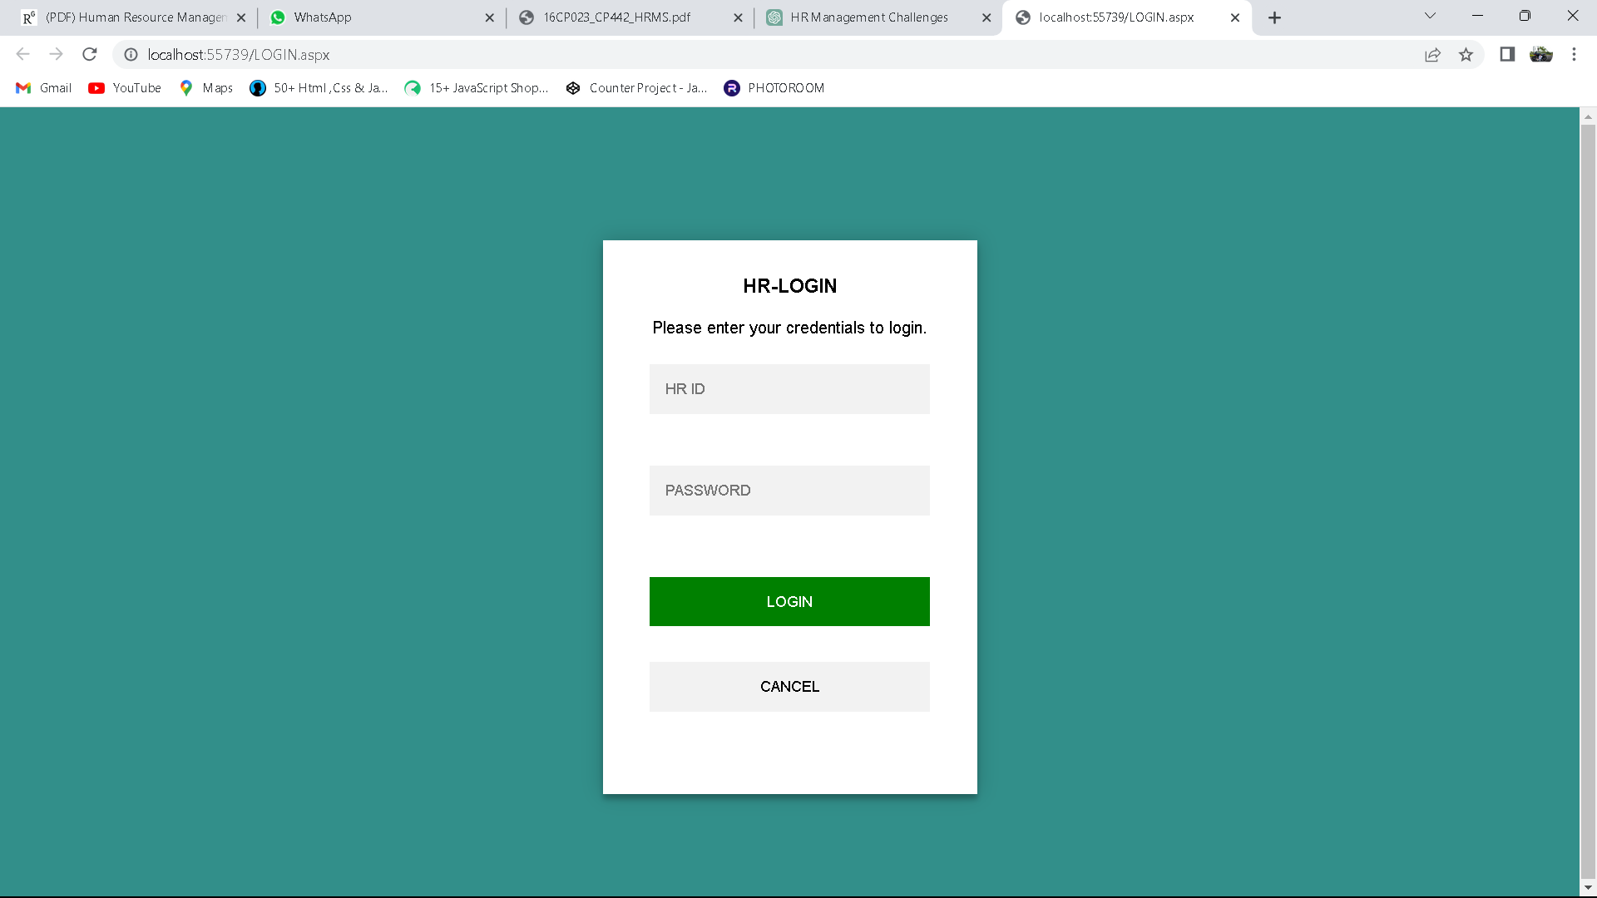

**HOME PAGE**

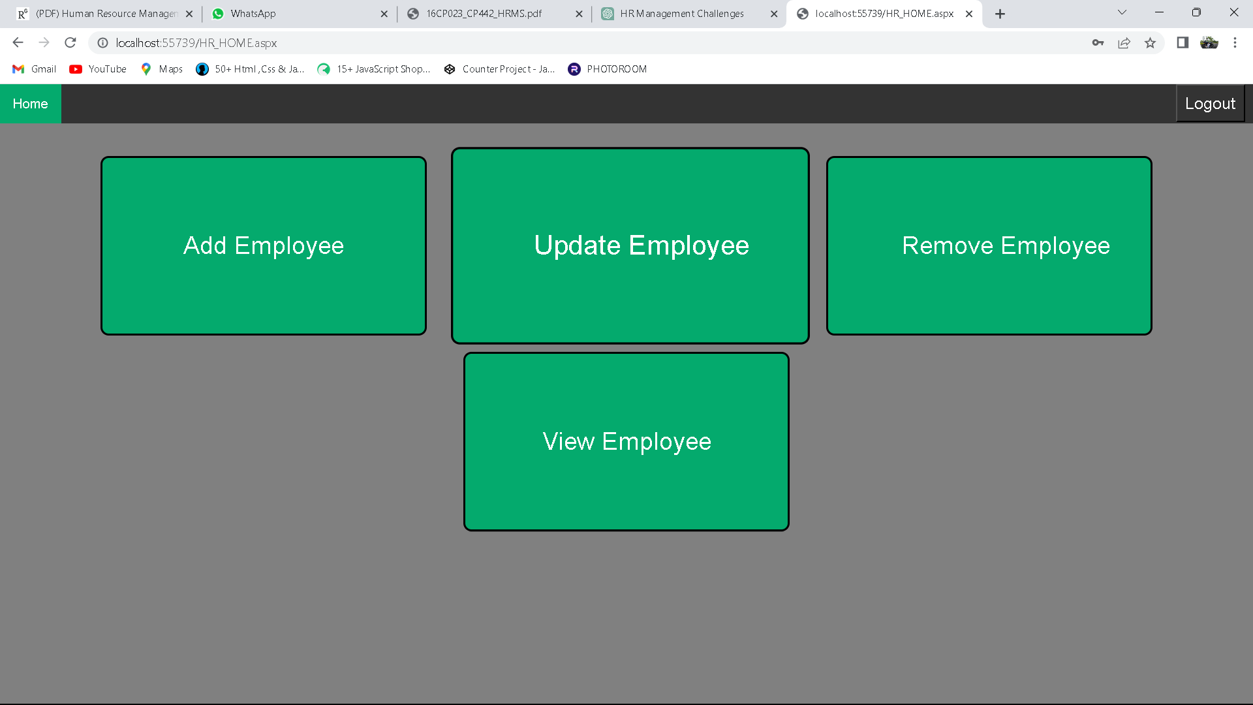

**ADD EMPLOYEE DATA PAGE**

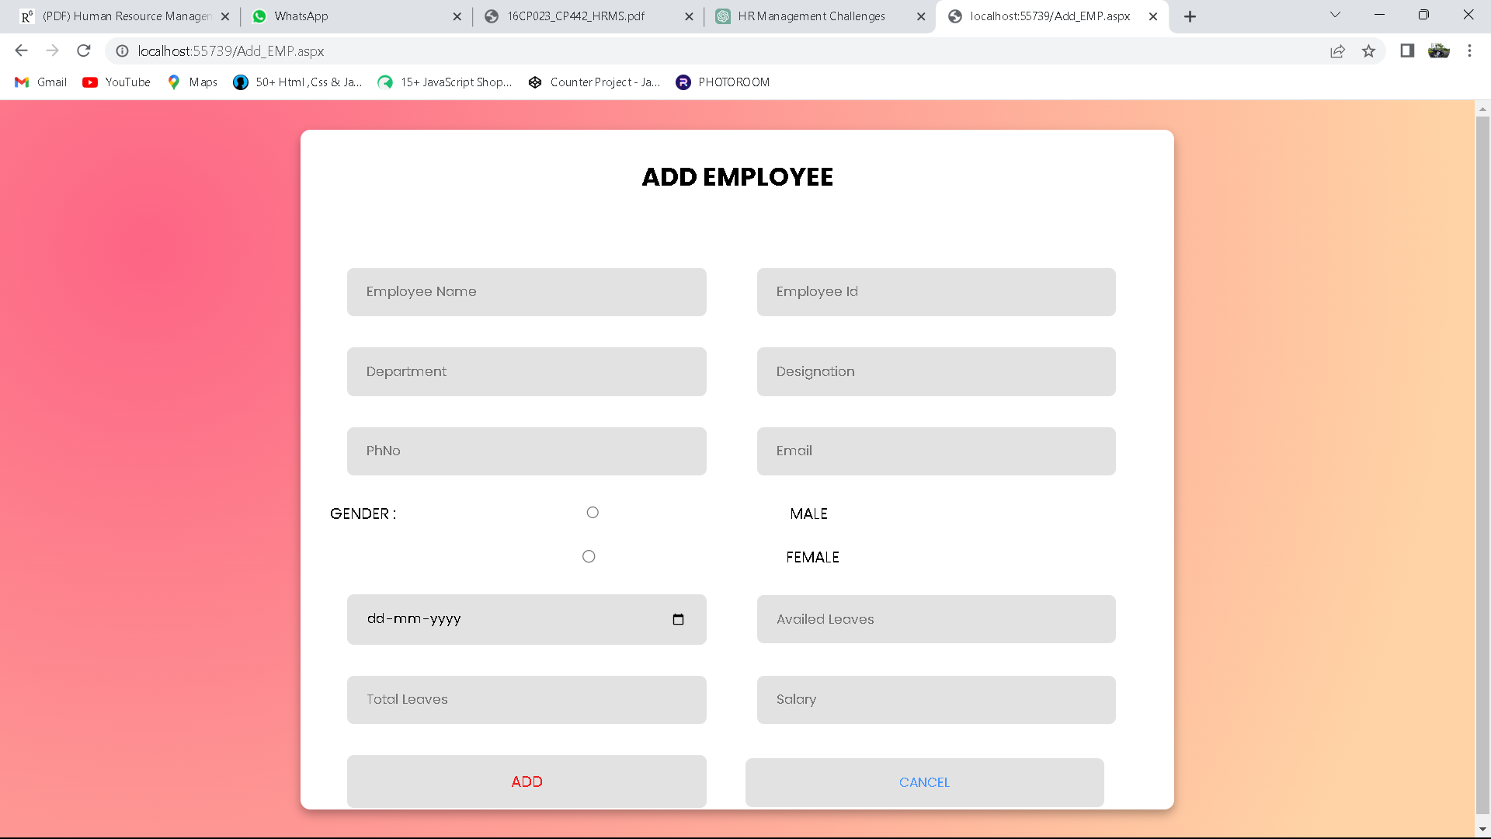

**UPDATE EMPLOYEE DATA PAGE**

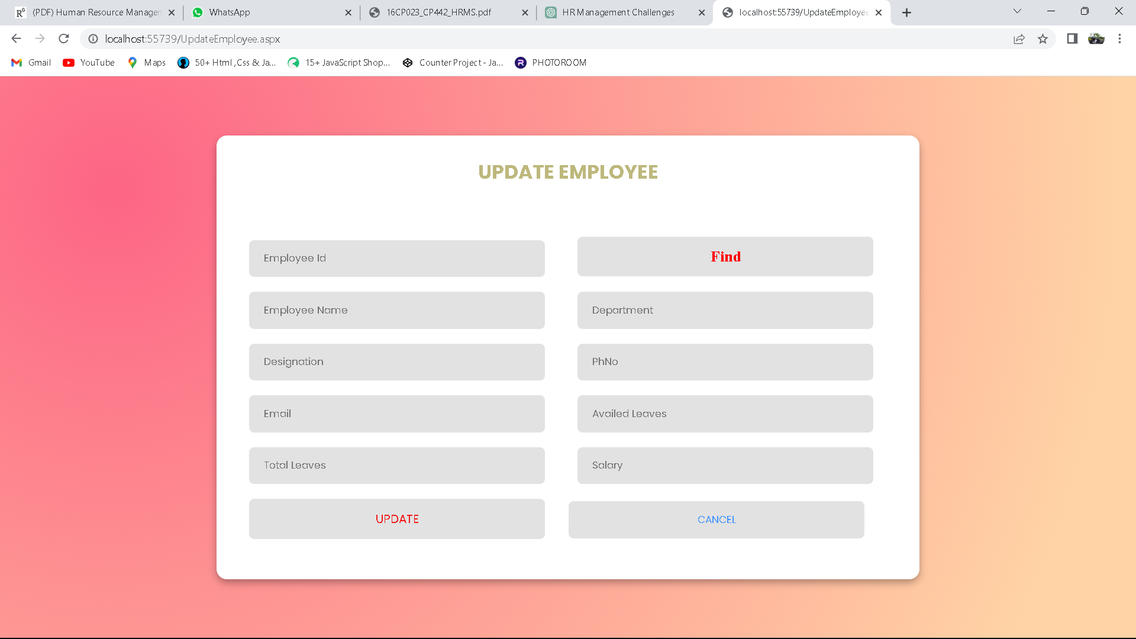

**REMOVE EMPLOYEE DATA PAGE**

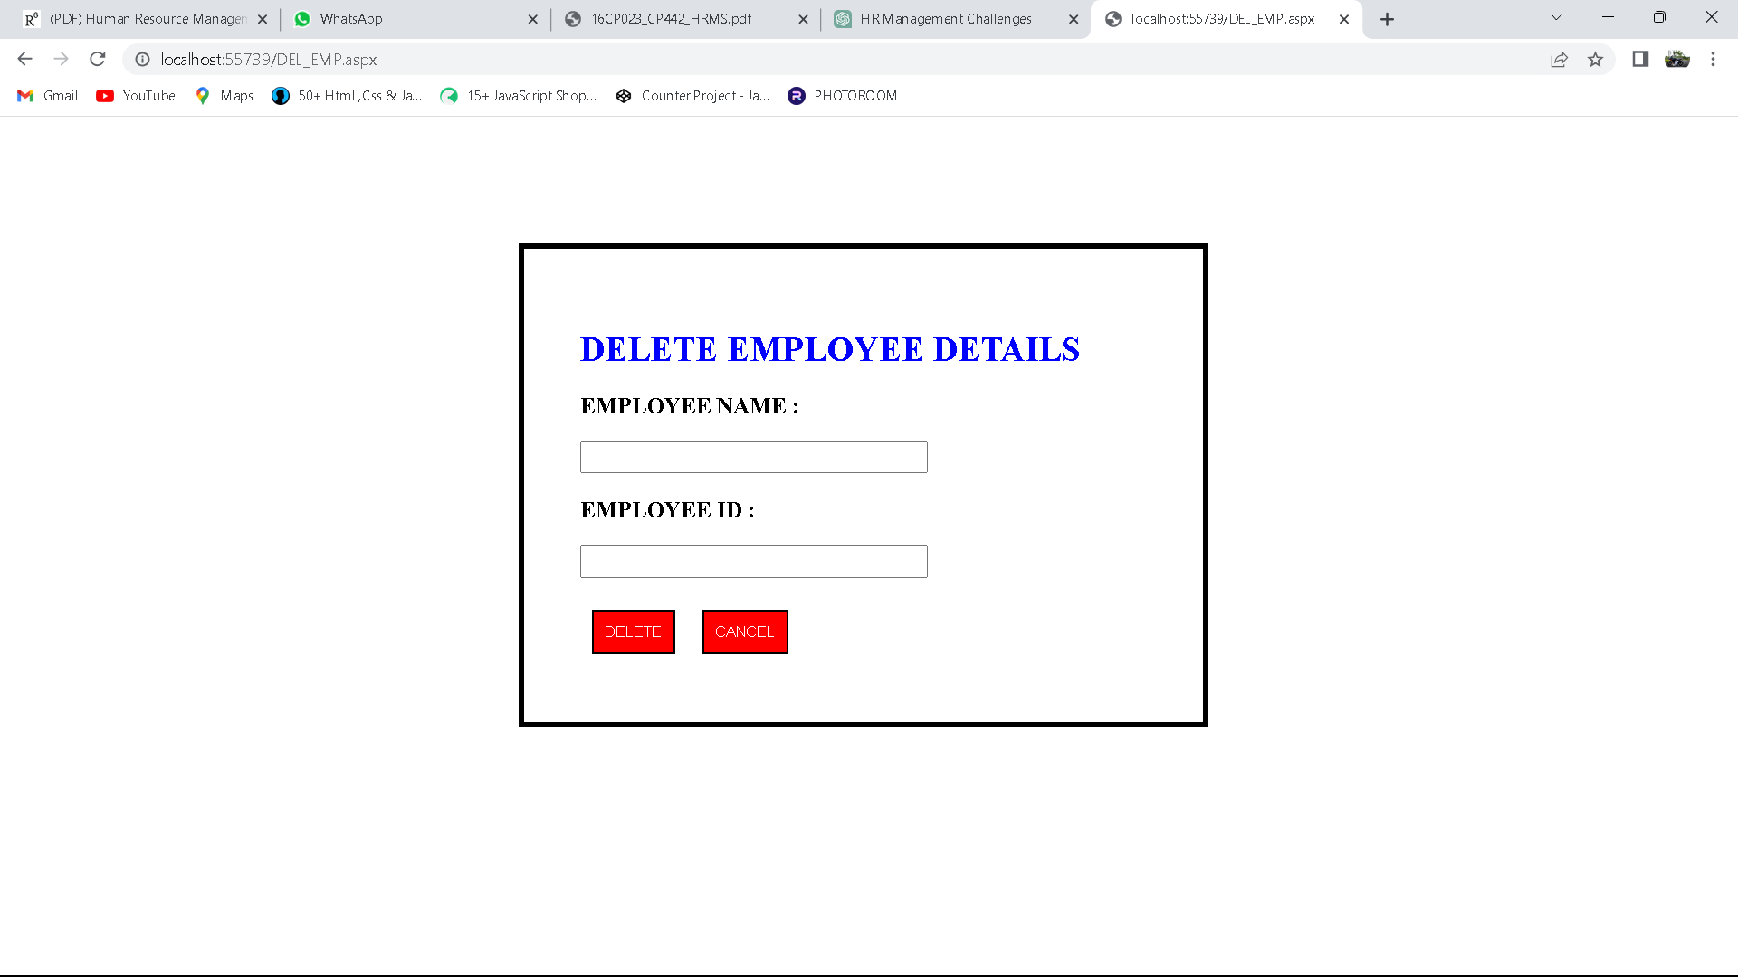

**VIEW EMPLOYEE DATA**

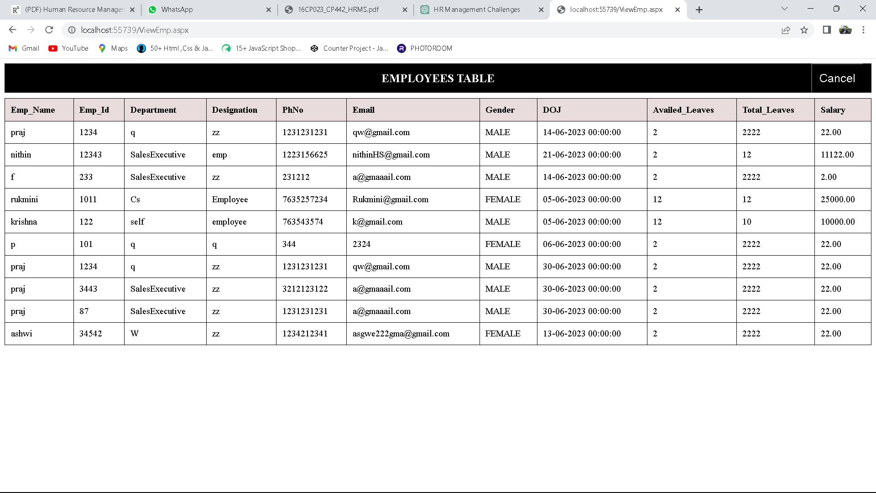

**5.3 DATABASE CONNECTIVITY :**

**EMPLOYEE_DATABASE**

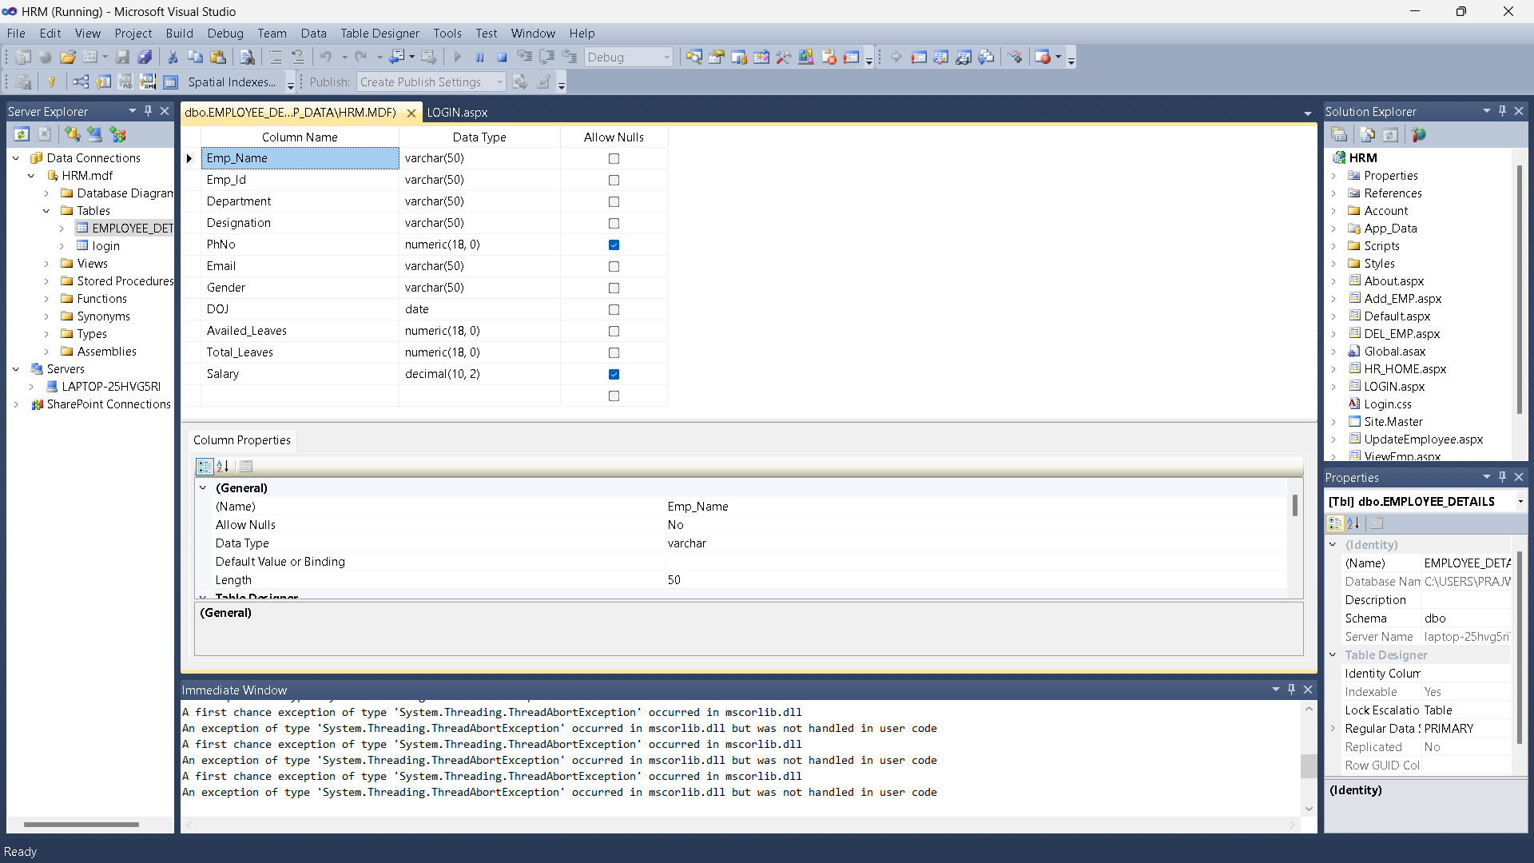

**ADD_EMPLOYEE**

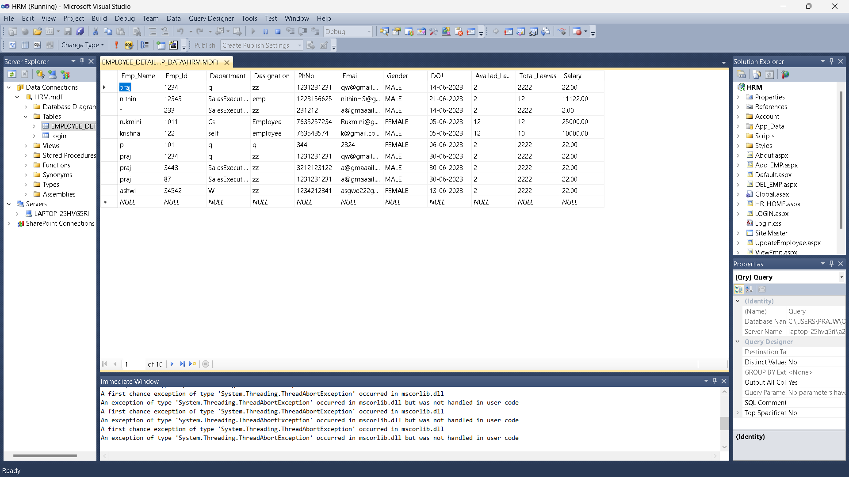

**LOGIN**

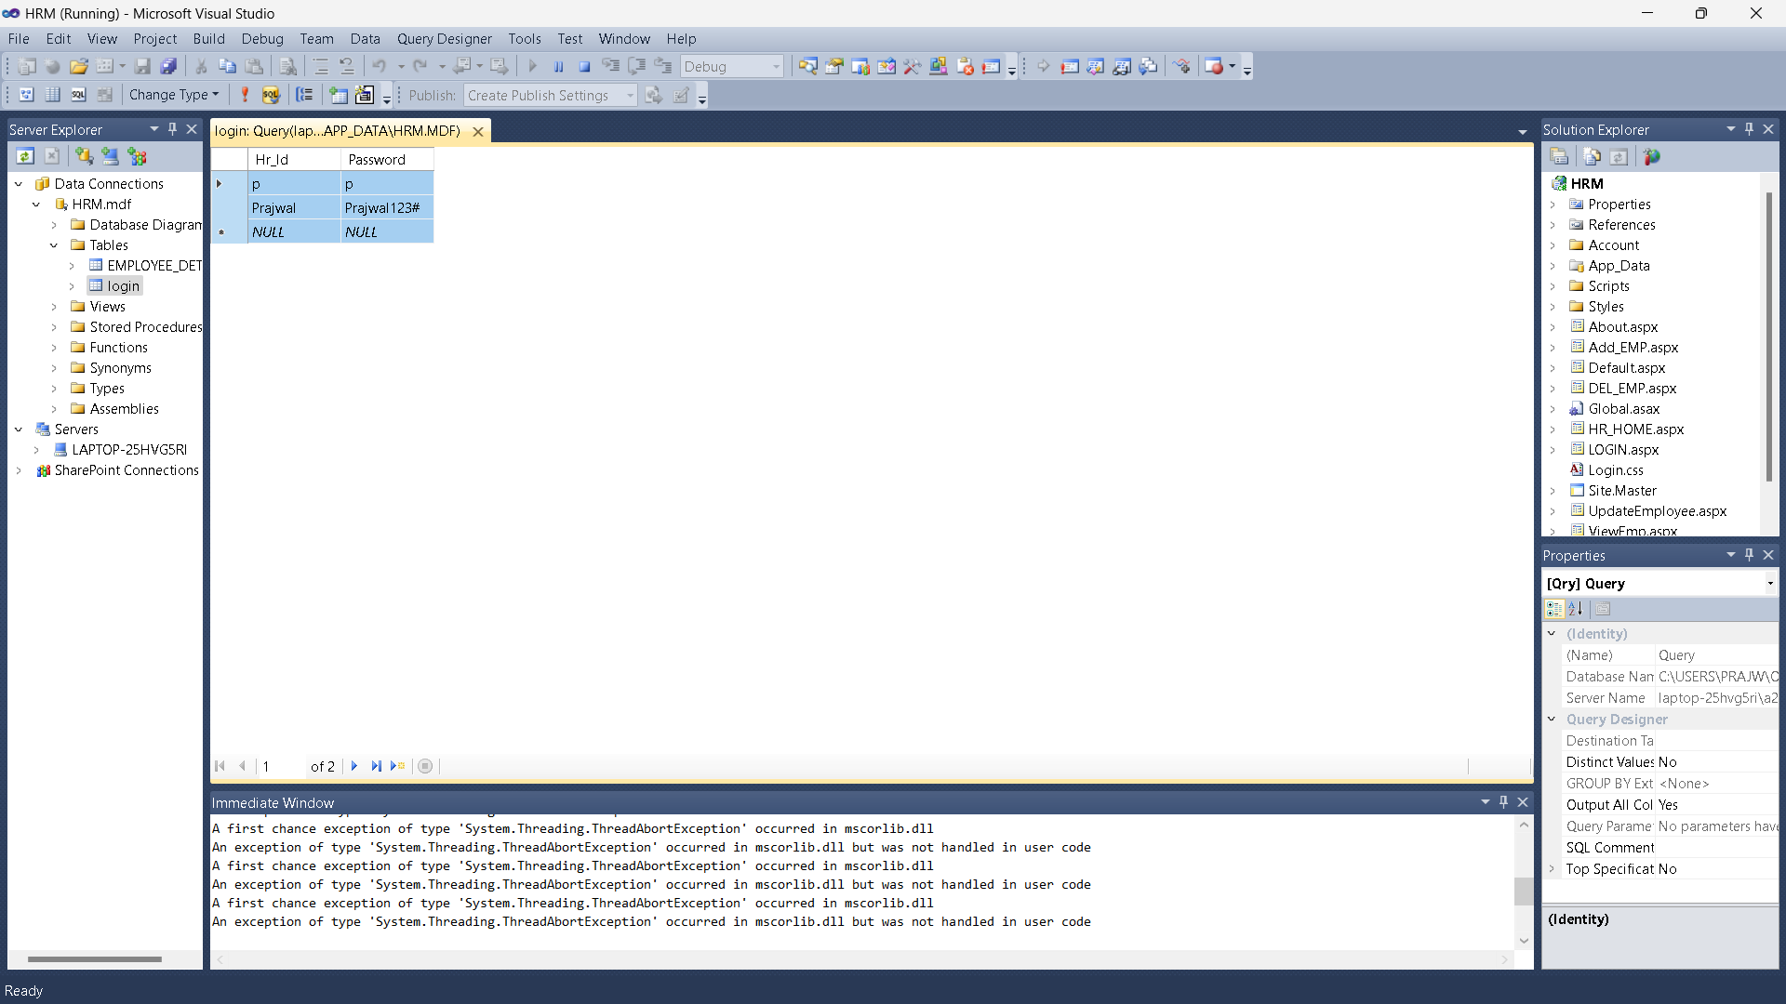

**CHAPTER 6**

**6.1 Conclusion**

**6.2 Future Enhancement**

**6.3 Biblography**

**6.1 CONCLUSION :**

This project is built keeping in mind that it is to be used by only one user that is the admin. It is built for use in small scale organization where the number of employees is limited. According to the requested requirement the admin can add, manipulate, update and delete all employee data in his organization. The admin can add new departments and delete them. The Admin can also add predefined pay grades for the employees. The required records can be easily viewed by the admin anytime time he wants in an instant. The payment of the employee is based on monthly basis. Numerous validations implemented would enable the admin to enter accurate data. The main objective of this framework is to save time, make the system cost effective and management records efficiently**.**

**6.2 FUTURE ENHANCEMENT :**

These future enhancements aim to leverage emerging technologies and address evolving needs in employee details management. By adopting these advancements, the system can become more efficient, user-friendly, and provide greater insights for HR professionals, ultimately contributing to better employee management and organizational success**.**

**6.3 BIBLOGRAPHY :**

**WEB SITE REFFERED**

[www.dotnet.microsoft.com](http://www.dotnet.microsoft.com)

[www.youtube.com](http://www.youtube.com)

[www.w3schools.com](http://www.w3schools.com)

www.javatpoint.com